**Steps to upload your files and submit a topgear project**

Step 1: Open url <https://topgear-app.wipro.com,login> with your credentilas.

Step 2: Join in any community and become a member.

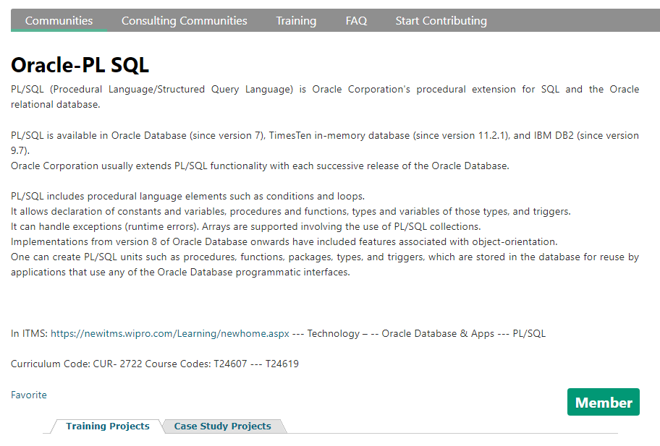

Step 3: Select any Training or Case study projects and start working on it by joining any project.

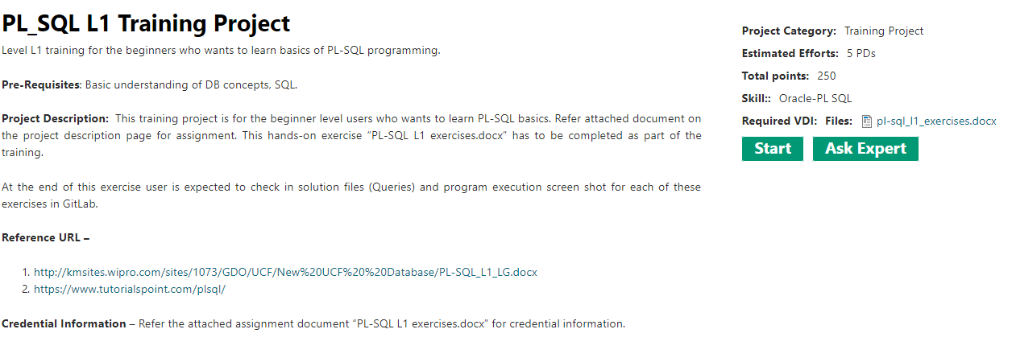

Step 4: You will find the document for project description, download it and prepare your file to which you have to upload for that project.

Step 5: While submitting the project, when you click on submit you will find the following page.

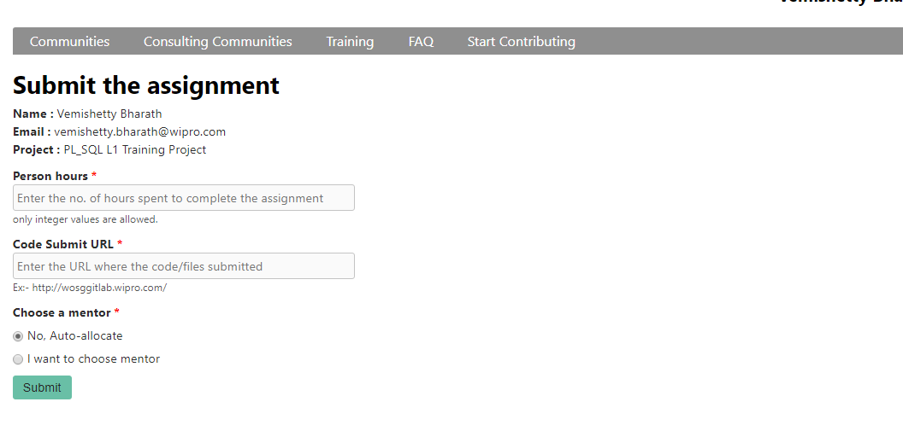

Step 6: Open that url <http://wosggitlab.wipro.com> and login with your credentials.

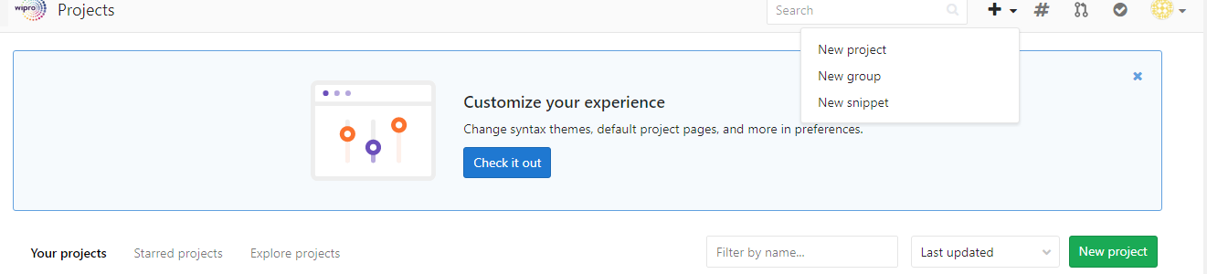

Step 7: Open a New project.

Step 8: Give your project name and put visibility level as public.

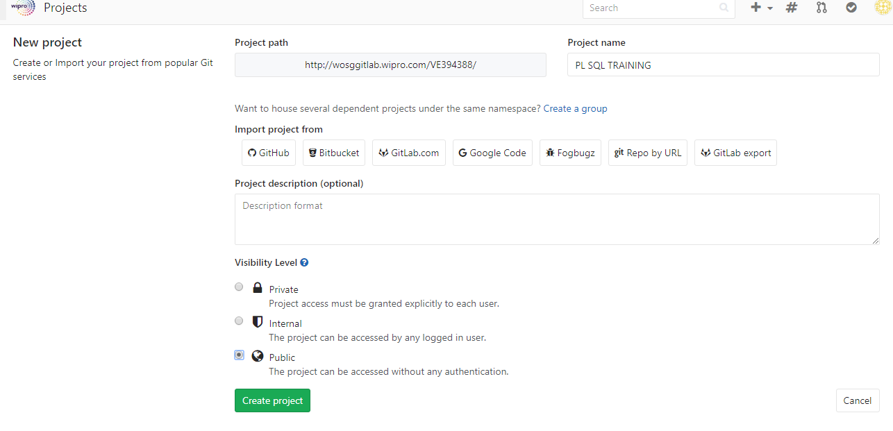

Step 9: Open README and just click commit changes then you will go to step 10.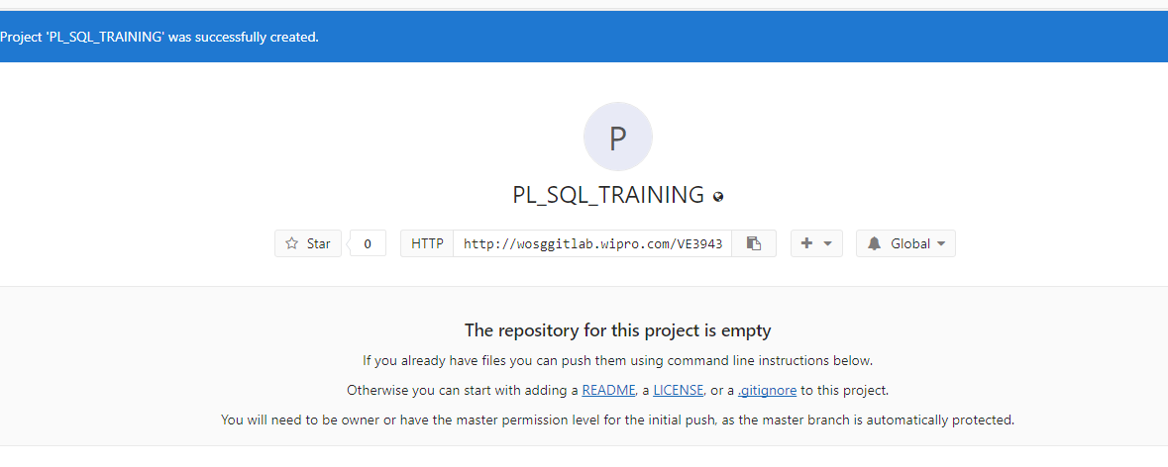

Step 10: 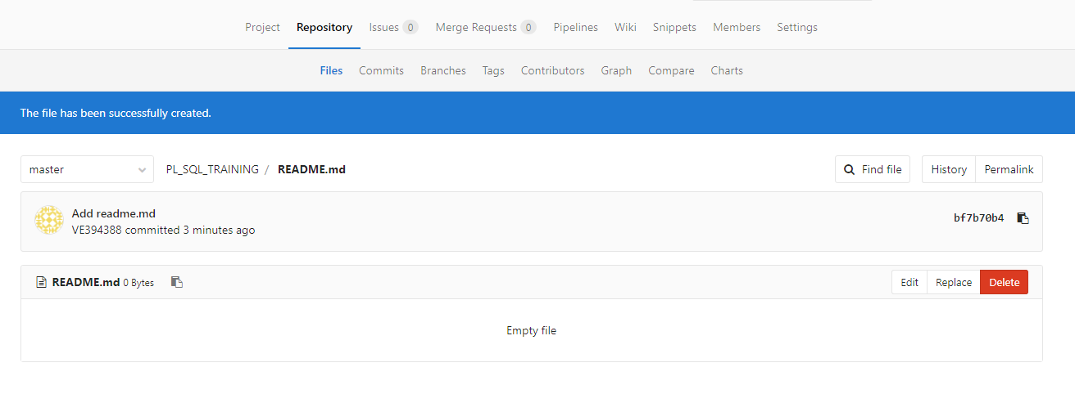

Step 11: Then go to project you will find an option to add file near your project name.

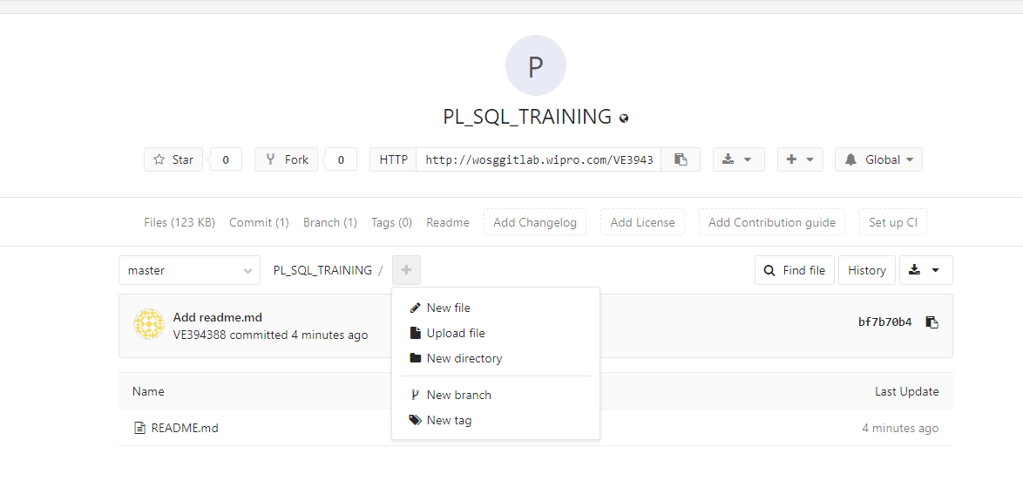

Step 12: Click on upload file.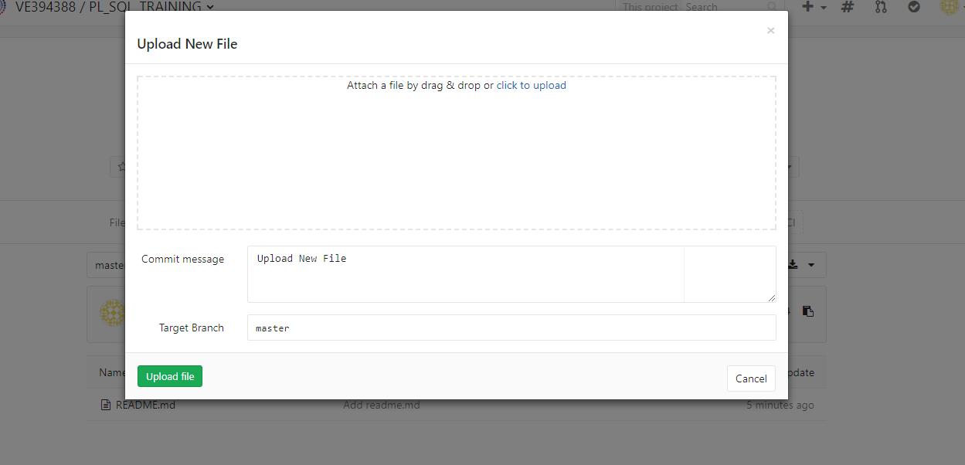

Here you can upload your file, if you have multiple files zip them as a single folder and upload it.

Step 13: Upload your file and copy your url and paste that url and enter number of working hours you worked on that project in project submission page and submit your project.

Note: You can select your mentor whom you want to review your project in that project submission page.